Volume
Find the volume for each shape. Use cubic units (un3) for your units.
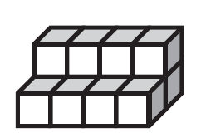
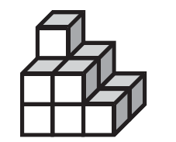
1. 2.

______________________ ______________________

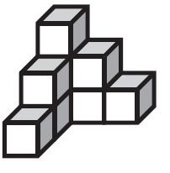
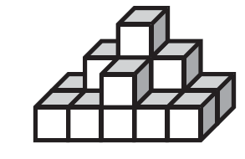
3. 4.

______________________ ______________________

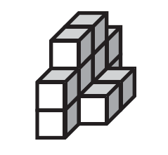
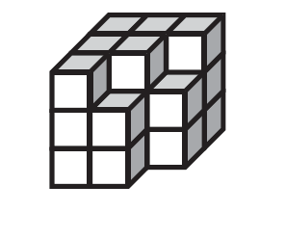
5. 6.

______________________ ______________________

Volume
Find the volume for each shape. Use cubic units (un3) for your units.
1. 2.

________12 units ³______ ________11 units ³______
3. 4.

________15 units ³______ ________9 units ³______

5. 6.

________22 units ³______ ________12 units ³______

