Volume
Find the volume for each shape. Use cubic units (un3) for your units.
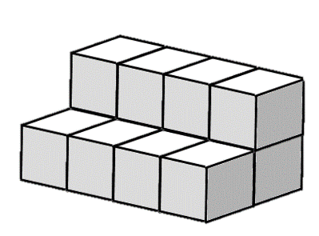
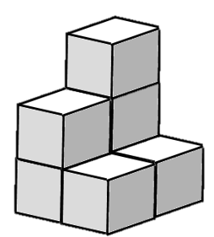
1. 2.

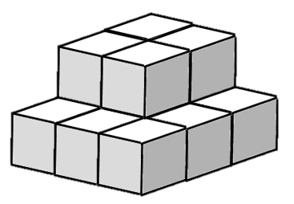
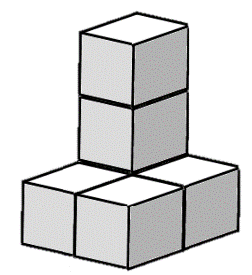
______________________ ______________________

3. 4.

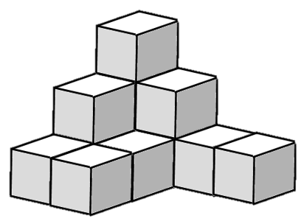
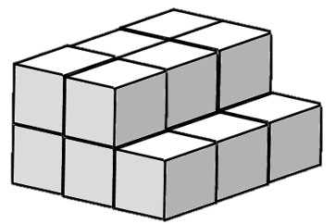
______________________ ______________________

5. 6.

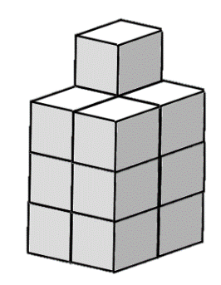
______________________ ______________________
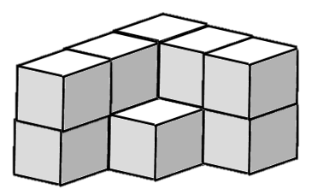
7. 8.

______________________ ______________________
Volume
Find the volume for each shape. Use cubic units (un3) for your units.
1. 2.

_________12 units ³_____ _________7 units ³_____

3. 4.

_________13 units ³_____ _________6 units ³_____

5. 6.

_________15 units ³_____ _________12 units ³_____
7. 8.

_________11 units ³_____ _________13 units ³_____

