Date: Monday April 20, 2020- Optional Zoom Meeting at 9:30am. Email me if you do not have the ID or Passwords (ID and Passwords remain the same each week)
Learning List: Writing
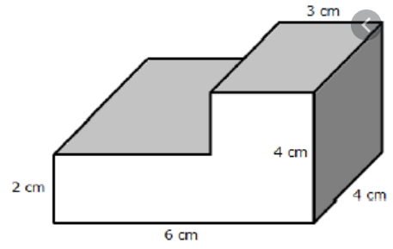
Last week, students were asked to fill out the ‘Generating Memories’ paper. That did not have to be shared with me. Today, students are to select two memories they listed on this paper and write the stories about each memory. The memories selected should be important to the student and there should be a reason why they select these memories beyond ‘It was a fun time’. Remember to write the who, what, when, where, why, and how of each story. These memories need to be written into Office 365 in the Matson and Holder Notebook. Create new pages and label one “Memory 1” and the other “Memory 2”. We will be doing further work with these memories, so make sure they are typed by Wednesday morning.
Math
- Have students watch this video. https://www.khanacademy.org/math/cc-fifth-grade-math/5th-volume/decompose-figures-to-find-volume/v/volume-in-unit-cubes-by-decomposing-shape
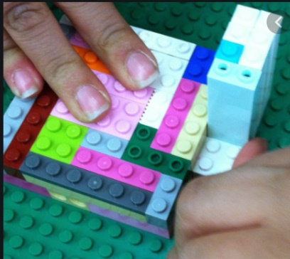
- Challenge! Students are to build with legos or any other building material, or draw a picture with dimensions (measurements) of an irregular rectangular shape. This shape must be more that a total of 10 cubic units in volume but no more than 50 cubic units of volume. The shape must have a gap in some portion of the shape. Students will build or draw their shape and upload it onto Flipgrid. Download the Flipgrid app on any smart device. Flip code is matson8550 and the password is VolumeChallenge (include capitals). Upload your video of your shape. Allow other students to guess the volume of your shape through flipgrid responses. If you need help with this, contact me.
Science
- Download the Physical and Chemical Changes powerpoint on the blog.
- Students go to Clever.com and click ‘Log In as a Student’. They should see the district of Cobb County Schools listed. If not, search and select Cobb County Schools. Students then click to log in with ACTIVE DIRECTORY. They will then log in using their information they use to log into the computers at school. They will then click the app Brainpop. They will search for “Property Changes”. Watch the video and take the quiz.
Optional Activities: Reading
Read for 30 minutes and complete an activity on the Reading Choice Board
Grammar
IXL- Prefixes pre- https://www.ixl.com/ela/grade-5/words-with-pre

Date: Tuesday April 21, 2020
Learning List: Reading
MobyMax.com Reading Informational OR Reading Literature lesson until an 85% is earned on that lesson.
Social Studies
Download from my blog the PowerPoint Civil Rights Movement part 2. Make sure to click the links to view the videos.
Grammar
IXL- Prefixes re- https://www.ixl.com/ela/grade-5/words-with-re
Optional Activities: Writing
Editing- Placing sentences in order https://www.ixl.com/ela/grade-5/order-sentences
Math
Download the ‘Problem Solving with Volume’ file from my blog. Print out pages 4-7 to complete. Answers are included in the file for self checking.

Date: Wednesday April 22, 2020
Learning List: Writing
From my blog- download the PowerPoint lesson “Memoir Writing Lesson 2” Follow the lesson in the PowerPoint and complete the assignment regarding the lesson from Monday on the final slide. These annotations should be uploaded into Office 365 in the ‘Matson and Holder Notebook’ by Friday where the memories were already inputted.
Math
Volume Practice- IXL
https://www.ixl.com/math/grade-5/volume-of-irregular-figures-made-of-unit-cubes
https://www.ixl.com/math/grade-5/volume-of-cubes-and-rectangular-prisms-word-problems (use a calculator if needed to calculate A=LxWxH)
Science
Download the Chemical and Physical Changes WebQuest file from my blog. Type answers onto the file and then click the ‘share’ button in the upper left hand corner and type my name to share your completed document with me.
Optional Activities: Reading
Read for 30 minutes and complete an activity on the Reading Choice Board
Grammar
IXL- Prefixes sub- https://www.ixl.com/ela/grade-5/words-with-sub

Date: Thursday April 23, 2020
Learning List: Reading
MobyMax.com Reading Informational OR Reading Literature lesson until an 85% is earned on that lesson.
Social Studies
MobyMax.com A Changing Nation Lesson has been assigned. Log in using your first and last name (no capitals, spaces, or punctuation) and the password 321. Once you click on it, it should say The Civil Rights Movement, Part 2. Use the information from yesterday to help you understand the ideas. If you need to retake the lesson, let me know and I can reset it.
Grammar
IXL- Prefixes mis- https://www.ixl.com/ela/grade-5/words-with-mis
Optional Activities: Writing
Editing- Correcting errors of frequently confused words https://www.ixl.com/ela/grade-5/correct-errors-with-frequently-confused-words
Math
Download the ‘Volume of Irregular Shapes I’ and ‘Volume of Irregular Shapes II’ files from my blog and complete. Answers are included in the files for self checking.

Date: Friday April 24, 2020- Optional Zoom Meeting at 9:30am. Email me if you do not have the ID or Passwords (ID and Passwords remain the same each week)

Effective Monday, April 13, 2020, the following guidelines are to be implemented at each school:
• Digital learning activities and lessons will take place Monday through Thursday.
- Friday will be a day for students to catch-up on any previously assigned lessons. Teachers will be able to collaborate and conference with peers, parents and/or students, assess student progress, and prepare future instructional lessons.
- No new instruction or assignments will be assigned or distributed to students on Fridays.

