**Grade 5 Mathematics**

**Unit 2: Decimals**

**End of Unit Study Guide**

Name _____________________________________ Date _________________________________

**Section 1: Proficiency of Skills (Selected Response)**

2) What is 630.162 written in word form?

1) Use the model to find the product:

0.2 x 0.7 = ________

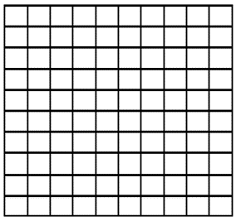

630.162



**MGSE5.NBT.3**

3) Round 27.38 to the nearest:

Tenths :_______________

Whole Number: ________________

Tens: _______________

4) Caleb has 5 craft projects he needs to make. He uses 0.7 of a meter of wood for each craft project. How much total wood will Caleb use?



**MGSE5.NBT.3**

6) Use the models to find the difference:

2.04 – 1.53 = _________

5) Use the models to find the sum:

2.67 + 0.92 = ________

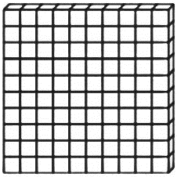

**MGSE5.NBT.7**

**MGSE5.NBT.7**

**Section 1: Proficiency of Skills (Constructed Response)**

7) Use the model to find the quotient: 3.4 ÷ 1.7 = ________

8) Dallas buys a burger for $6.34, fries for $4.38, and a soda for $2.29. If he pays with a $20 bill, how much change will he receive? Show your work in the space below.

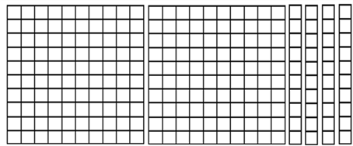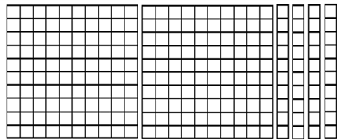

9) Put the numbers in order from **Greatest** to **Least**:

|  |  |  |  |
| --- | --- | --- | --- |
| **7.6** | **7.628** | **7.63** | **7.609** |

________ _________ _________ _________

**MGSE5.NBT.3**

13) Use the symbols >, <, or = to compare the numbers.

463.60 ______ 463.6

14) Write the number in standard form and expanded form:

**five hundred sixty-seven and eighty-four hundredths**

Standard Form: _____________________________________________________________________________________________________________________

­­ Expanded Form: ____________________________________________________________________________________________________________________



**MGSE5.NBT.3**

**MGSE5.NBT.3**

12) Use the symbols >, <, or = to compare the numbers.

42.175 ______ 42.36

11) Write the multiplication sentence that is represented by the area model.

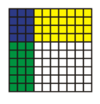

**__________ × __________ = ___________** 

**MGSE5.NBT.3**

10) Jenny read for 2.05 hours on Monday, 1.25 hours on Tuesday, and 0.75 hours on Wednesday. How many total hours did Jenny read for?



**MGSE5.NBT.7**

16) Use the models to find the difference:

2.34 – 1.53 = _________

15) Use the models to find the sum:

1.37 + 2.23 = ________

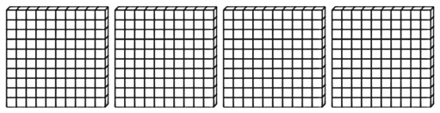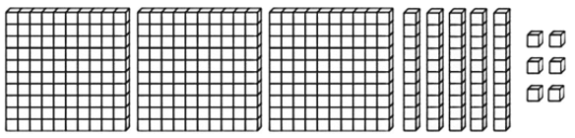

**MGSE5.NBT.7**

**MGSE5.NBT.7**

**Section 2: Knowledge and Understanding**

|  |
| --- |
| 17) Michael is trying to solve 4.55 ÷ 0.65 using decimal models. Show Michael how to find the quotient using the model. Write the quotient on the line.  4.55 ÷ 0.65 = ________  **MGSE5.NBT.7** |
| 18) Keegan says that the product of 7 x 3.5 is more than 21. Determine if Keegan is correct or not, and explain how you got your answer.  Keegan is ___________________________.  Explanation: _________________________________________________________________________________________________________________________  ___________________________________________________________________________________________________________________________________  ___________________________________________________________________________________________________________________________________  **MGSE5.NBT.7**  ___________________________________________________________________________________________________________________________________  19) Preston is calculating the area of a garden. The length of the garden is 3.8 meters, and the width is 5.1 meters. Find the total area of the garden.  *Area = Length x Width*    The area of the garden is ___________ m2.  **MGSE5.NBT.7** |
| 20) Margo purchased a set of 4 different apps from the app store. Each app costs $5.99. What is the total price of all the apps?  The total cost is $____________.  **MGSE5.NBT.7** |
| 21) Create a model that shows 4.8 ÷ 2. Then write the Quotient on the line:  4.8 ÷ 2 = ________  **MGSE5.NBT.7** |

**Section 3: Application**

|  |
| --- |
| 22) Trevor needs $18.00 (including tax) to buy a video game. He has earned some money from his weekly chores. The amounts he earned are shown below:  **$4.63**  Vacuuming  **$____.____ ____**  Dusting  **$5.52**  Raking Leaves  **$3.57**  Walking the Dog  Trevor will be dusting the furniture on Saturday. How much money does Trevor need to have enough money to buy the video game?  Show your work and write your final answer in the Dusting box above.    **MGSE5.NBT.7** |
| 23) Samuel places a piece of yellow yarn that is 18.6 feet long on the track at her school. He cuts the yarn into sections that are 6.2 feet long. How many sections of yellow yarn does Samuel have now?  **MGSE5.NBT.7** |
| 24) Jessica runs 3.2 miles each day. How many total miles will Jessica run over 18 days?  **MGSE5.NBT.7** |

**Section 4: Performance Task**

|  |
| --- |
| 25) Marielle and Bryce are discovering about decimals in math class.  **PART A**:  Marielle needs to show 1.05 using decimal models. Show 1.05 on the model below:    **PART B**:  Bryce needs to show 2.8 using decimal models. Show 2.8 on the model below:      **PART C**:  Use the symbols >, <, and = to compare the two decimals shown by the shaded parts of the grids.  1.05    2.8  **PART D**:  Find the difference between 2.8 and 1.05. Use the decimal grids in parts A and B to help you.  **MGSE5.NBT.3**  **MGSE5.NBT.7** |

**Grade 5 Mathematics**

**Unit 2: Decimals**

**End of Unit Study Guide**

Name _____**KEY**________________________________ Date _________________________________

**Section 1: Proficiency of Skills (Selected Response)**

2) What is 630.162 written in word form?

Six Hundred Thirty and One Hundred Sixty-Two Thousandths

1) Use the model to find the product:

0.2 x 0.7 = _0.14_______



630.162





**MGSE5.NBT.3**

3) Round 27.38 to the nearest:

Tenths :__27.40_____________

Whole Number: ___27.00_____________

Tens: ___30.00____________

4) Caleb has 5 craft projects he needs to make. He uses 0.7 of a meter of wood for each craft project. How much total wood will Caleb use?

5 x 0.7 = 3.5



**MGSE5.NBT.3**

6) Use the models to find the difference:

2.04 – 1.53 = __0.51_______

5) Use the models to find the sum:

2.67 + 0.92 = _3.59_______





**MGSE5.NBT.7**

**MGSE5.NBT.7**

**Section 1: Proficiency of Skills (Constructed Response)**

7) Use the model to find the quotient: 3.4 ÷ 1.7 = __2______

8) Dallas buys a burger for $6.34, fries for $4.38, and a soda for $2.29. If he pays with a $20 bill, how much change will he receive? Show your work in the space below.

6.34 + 4.38 + 2.29 = 13.01

20 – 13.01 = $6.99



2

1

9) Put the numbers in order from **Greatest** to **Least**:

|  |  |  |  |
| --- | --- | --- | --- |
| **7.6** | **7.628** | **7.63** | **7.609** |

___7.63___ __7.628_____ ___7.609____ ___7.6____

**MGSE5.NBT.3**

13) Use the symbols >, <, or = to compare the numbers.

463.60 ___=___ 463.6

14) Write the number in standard form and expanded form:

**five hundred sixty-seven and eighty-four hundredths**

Standard Form: ________567.84_______________________________________________________________________________________________

­­ Expanded Form: ______(5x100) + (6x10) + (7x1) + (8x1/10) + (4x1/100)____________________________________________



**MGSE5.NBT.3**

**MGSE5.NBT.3**

12) Use the symbols >, <, or = to compare the numbers.

42.175 ___<___ 42.36

11) Write the multiplication sentence that is represented by the area model.



**____0.3___ × ___0.4____ = ___0.12_____** 

**MGSE5.NBT.3**

10) Jenny read for 2.05 hours on Monday, 1.25 hours on Tuesday, and 0.75 hours on Wednesday. How many total hours did Jenny read for?

2.05 + 1.25 + 0.75 = 4.05



**MGSE5.NBT.7**

16) Use the models to find the difference:

2.34 – 1.53 = __0.81_______

15) Use the models to find the sum:

1.37 + 2.23 = __3.60______





**MGSE5.NBT.7**

**MGSE5.NBT.7**

**Section 2: Knowledge and Understanding**

|  |
| --- |
| 17) Michael is trying to solve 4.55 ÷ 0.65 using decimal models. Show Michael how to find the quotient using the model. Write the quotient on the line.  4.55 ÷ 0.65 = ___7_____  1 2 3 4 5 6 7  **MGSE5.NBT.7** |
| 18) Keegan says that the product of 7 x 3.5 is more than 21. Determine if Keegan is correct or not, and explain how you got your answer.  Keegan is ___Correct________________________.  Explanation: ___7 x 3 is 21. The problem is taking 7 and multiplying it by 3 plus 0.5 more. The answer will be more than 21 because 7x3.5 will be larger than 21. When I do the math, 7x3.5 is 24.5, which is more than 21. _______________________________________________________________________________________  ______________________________________________________________________________________________________________________________________  **MGSE5.NBT.7**  ___________________________________________________________________________________________________________________________________  19) Preston is calculating the area of a garden. The length of the garden is 3.8 meters, and the width is 5.1 meters. Find the total area of the garden.  *Area = Length x Width*    **3.8 x 5.1 = 19.38**  The area of the garden is __19.38_________ m2.  **MGSE5.NBT.7** |
| 20) Margo purchased a set of 4 different apps from the app store. Each app costs $5.99. What is the total price of all the apps?  4 x 5.99 = 23.96  The total cost is $__23.96__________.  **MGSE5.NBT.7** |
| 21) Create a model that shows 4.8 ÷ 2. Then write the Quotient on the line:  4.8 ÷ 2 = __2.4______  **MGSE5.NBT.7** |

**Section 3: Application**

|  |
| --- |
| 22) Trevor needs $18.00 (including tax) to buy a video game. He has earned some money from his weekly chores. The amounts he earned are shown below:  **$4.63**  Vacuuming  **$__4_._2__ _8__**  Dusting  **$5.52**  Raking Leaves  **$3.57**  Walking the Dog  Trevor will be dusting the furniture on Saturday. How much money does Trevor need to have enough money to buy the video game?  Show your work and write your final answer in the Dusting box above.    3.57 + 4.63 + 5.52 = 13.72  18 - 13.72 = 4.28  **MGSE5.NBT.7** |
| 23) Samuel places a piece of yellow yarn that is 18.6 feet long on the track at her school. He cuts the yarn into sections that are 6.2 feet long. How many sections of yellow yarn does Samuel have now? 18.6  - 6.2 🡨One section  12.4 3 total sections of yellow string  - 6.2 🡨One section  6.2  - 6.2 🡨 One Section  0.0  **MGSE5.NBT.7** |
| 24) Jessica runs 3.2 miles each day. How many total miles will Jessica run over 18 days?  3.2 x 18 = 57.6 miles  **MGSE5.NBT.7** |

**Section 4: Performance Task**

|  |
| --- |
| 25) Marielle and Bryce are discovering about decimals in math class.  **PART A**:  Marielle needs to show 1.05 using decimal models. Show 1.05 on the model below:    **PART B**:  Bryce needs to show 2.8 using decimal models. Show 2.8 on the model below:      **PART C**:  Use the symbols >, <, and = to compare the two decimals shown by the shaded parts of the grids.  <  1.05    2.8  **PART D**:  Find the difference between 2.8 and 1.05. Use the decimal grids in parts A and B to help you.  2.8 – 1.05 = 1.75  **MGSE5.NBT.3**  **MGSE5.NBT.7** |